* Launch templates: creating for new ec2-instance.

AMI, Instance Type (t2.large {2vpu, 8Gib}& t3.large), Key Pair, VPC, Security Group, Storage(Volume).

* Volume types: General Purpose SSD volumes can burst to 3000 IOPS, and deliver a consistent baseline of 3 IOPS/GiB, Provisioned IOPS SSD volumes can deliver up to 64000 IOPS, and are best for EBS-optimized instances.
* Instance Type: Spot, Reserved
* Copy IAM from one region to other: Create image from available instance in ec2 dash board, then after go to AMIs and chose created AMI and copy AMI to another region.

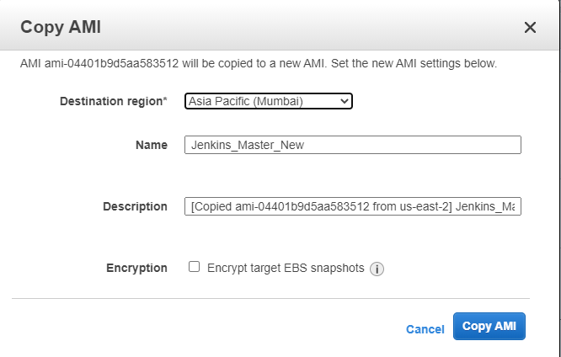

* Copy image from one account to another account using Modify Image permission.

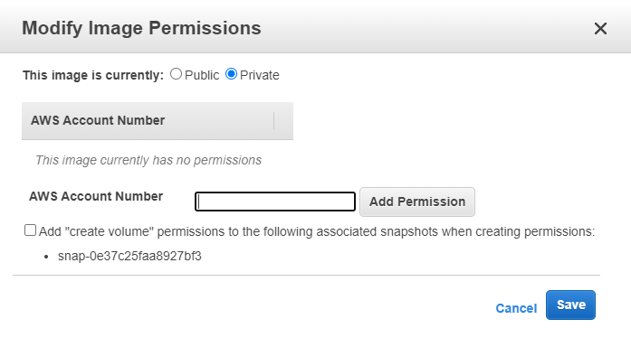

* Load Balancer: Application L7 & Network L4

Application: aware of application and provide path based routing.

Network: not aware of application and simply forward traffic from client to backend (Ec2 server)

* Auto Scaling: it is a function it allows you to provision and launch new instance whenever there is a demand. It allows you to automatically increase or decrease resource capacity in relation to the demand.
* Cloud Watch: concerned mainly with what’s happening with AWS resource so you can respond to it.
* Cloud Trail: concerned mainly with who did what did on aws.
* IP Address: communicate between two devices we need IP address IPv4 => 172.16.11.48 – 32-bit.
* Private network is non-routable IP (VPN): We can connect private network over the VPN.
* Public IP: We can connect over the internet.
* 10.0.1.100 (AddressSpace) /16(Mask).
* Region (us-east-1)-> Available Zone (us-east-1a)
* Subnet mask: 10.1.0.0/16 -> 255.255.0.0 (sm)
* VPC is a logical boundary & VPC is region based but it can extend between AZ.
* S3: It's built to store, protect and retrieve data from “**buckets**” at any time from anywhere on any device. As **AWS** describes it, an **S3** environment is a flat structure. A user creates a **bucket**, and the **bucket** stores objects in the cloud.